ITP 359, SUMMER 2024

Homework 3
20 points
AUTOENCODER

Colorize CIFAR10 dataset using an autoencoder.

airplane | 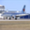 |  | 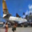 | 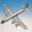 |  | 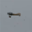 | 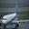 | 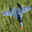 | 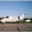 | 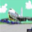
automobile | 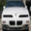 | 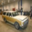 | 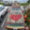 | 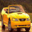 | 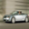 | 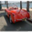 | 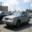 | 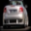 | 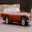 | 
bird | 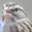 | 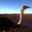 | 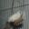 | 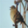 | 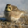 | 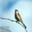 | 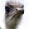 | 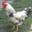 | 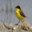 | 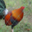
cat | 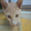 | 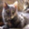 | 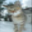 | 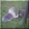 | 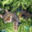 | 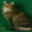 | 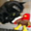 | 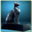 |  | 
deer | 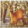 | 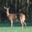 | 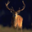 | 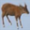 | 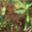 | 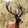 | 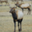 | 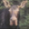 | 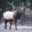 | 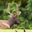
dog | 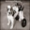 | 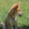 |  | 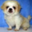 |  | 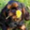 |  | 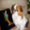 | 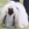 | 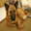
frog | 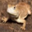 | 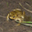 | 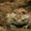 | 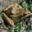 | 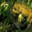 | 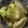 | 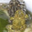 | 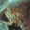 | 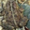 | 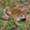
horse | 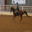 | 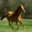 | 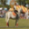 | 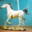 | 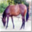 | 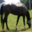 | 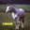 | 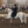 | 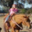 | 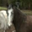
ship | 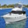 |  | 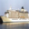 | 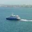 | 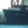 | 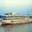 |  |  | 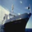 | 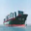
truck | 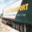 | 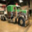 | 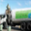 | 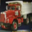 | 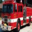 | 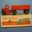 | 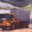 | 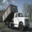 | 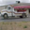 | 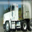

This is a dataset of 50,000 32x32 color training images and 10,000 test images, labeled over 10 categories. See more info at the CIFAR homepage.
- Load CIFAR10 dataset can be directly into you Python program using keras. (1)
- Assign the train and test datasets (1)
- Visualize 100 images from the train dataset. (2)
- Scale the images (if necessary) (1)
- Convert RGB images to LAB images (train dataset). (3)
- Setup the shapes of X and Y (1)
- Build the autoencoder network (3)
- Train the model (2)
- Visualize 10 color images as well as their grayscale images, and their colorized images (from the test dataset). (6)

